ID: 180917

Course: Software Testing

Date: May 05, 2019

Class Summary

In the class on the date above we learnt about web testing automation using Cucumber/Gherkin, specifically the frontend. In order to carry out frontend testing using cucumber the selenium framework is required in order to control the browser. Once the selenium gem has been installed the relevant web driver is needed to control a web browser.

Class Debugging Exercise

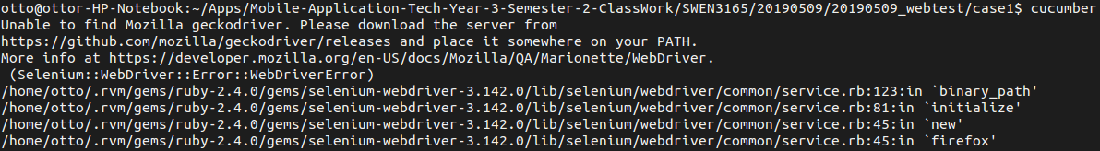

Upon launching the test cases with cucumber I received the error above, stating that the Firefox Gecko driver could not be found. In order to resolve this error I placed the Gecko driver file in the **/usr/local/bin** directory as root which resolved the error and I was now able to carry out the tests cases. When the test cases were re-run the following error was received:

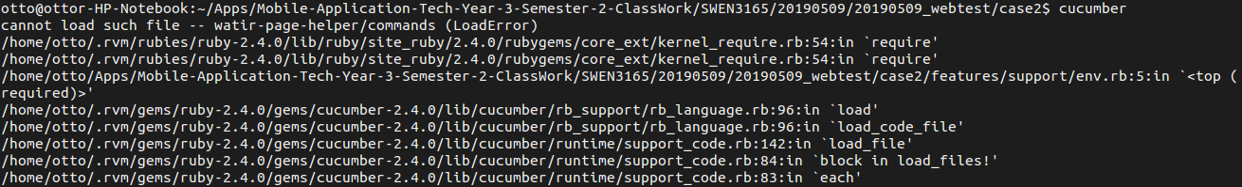

In an attempt to resolve the error I created the missing ‘commands’ ruby file in **./lib/watir-page-helper** and the error changed to:

Based on the errors I assumed that this is where the code to be implemented should be placed.